**LEASE MANAGEMENT**

**College name:** St. Joseph’s college for women.

**College code:** bru4i

**TEAM ID:** NM2025TMID22043

**TEAM MEMBERS:**4

**Team leader Name:** RAMITHA.S

**Email:** ramirami85711@gmail.com

**Team member1:** NANDHINI.M

**Email:** nandhini.murugan500@gmail.com

**Team member2:** AFREEN.M

**Email:** [afreenafreen7615@gmail.com](mailto:afreenafreen7615@gmail.com)

**Team member3:** HARINI.A

**Email:** [hariniangamuthu@gmail.com](mailto:hariniangamuthu@gmail.com)

**INTRODUCTION**

**PROJECT OVERVIEW:**

A lease management project involves creating a system or application to efficiently handle the processes related to leasing real estate properties, equipment, or other assets.

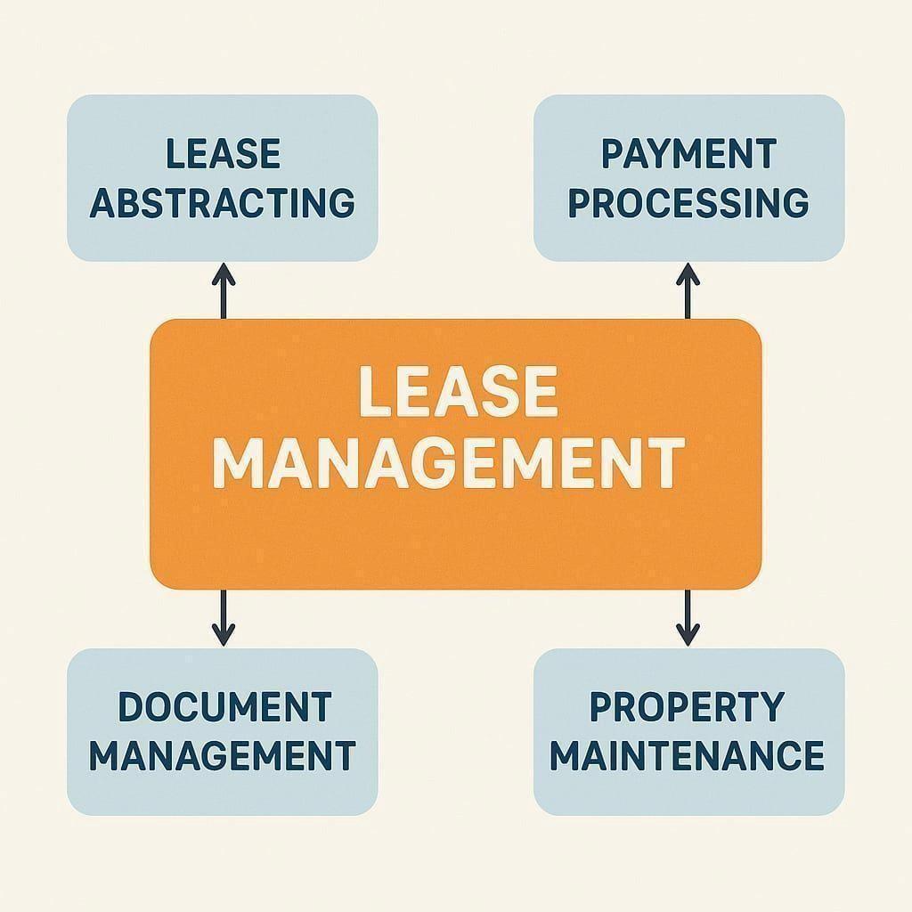

**PURPOSE:**

The main objective of the project is to enable organizations to efficiently manage properties, tenants, and lease-related activities. It reduces manual intervention, improves accuracy, and ensures better compliance and communication.

**DEVELOPMENT PHASE**

**Creating Developer Account:**

By using this URL:<https://developer.salesforce.com/signup>

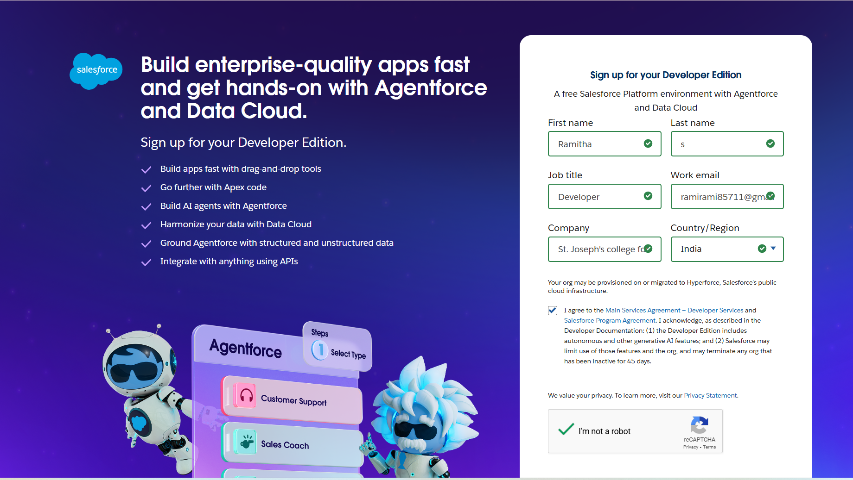

Created objects: Property, Tenant, Lease, Payment

**OBJECT**

Creating object

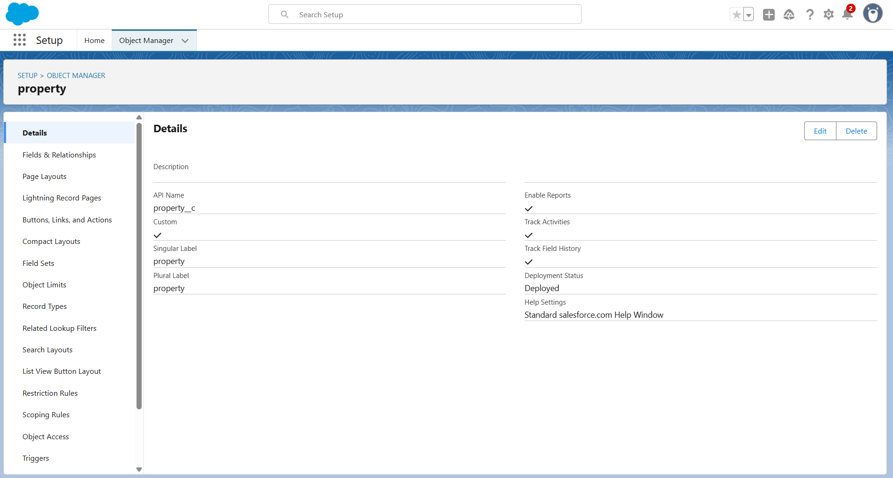

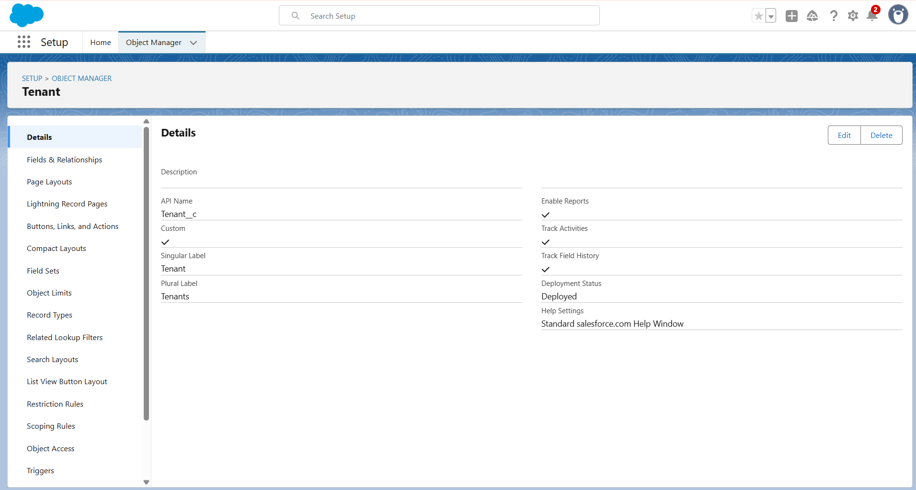

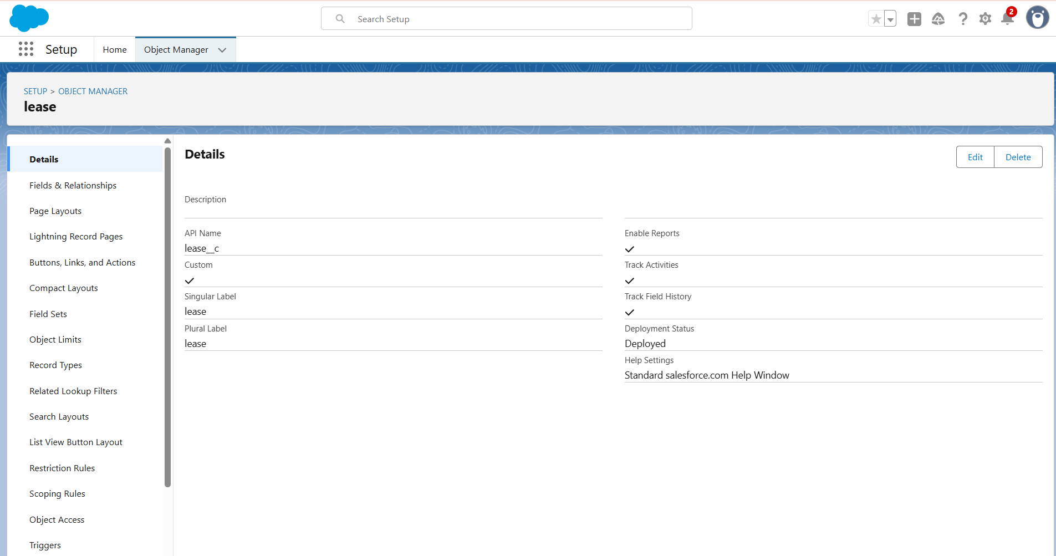

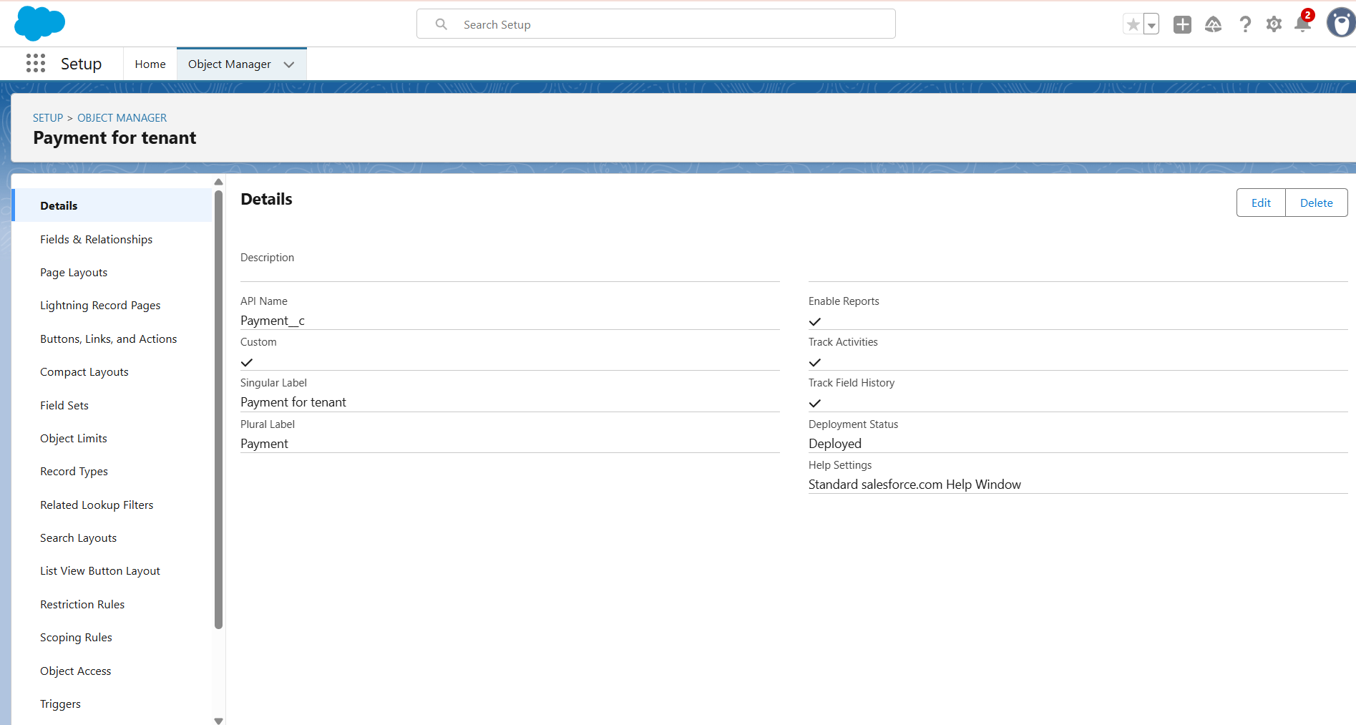

**TABS**

Creating a Custom Tab

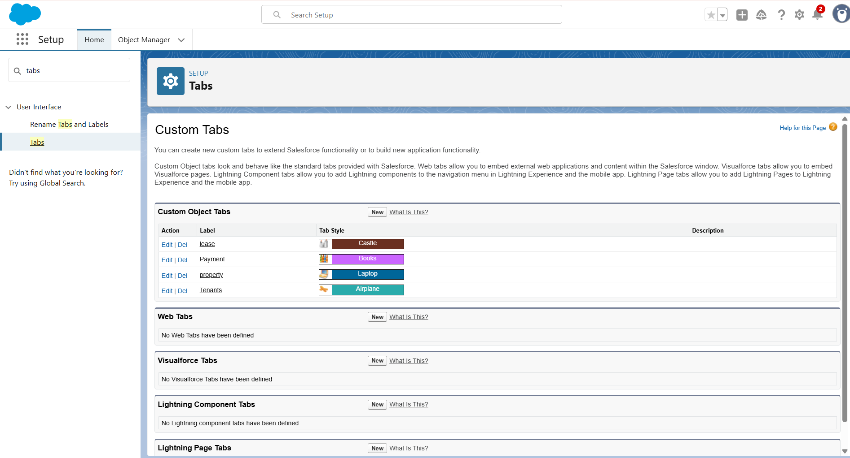

**FIELDS AND RELATIONSHIPS**

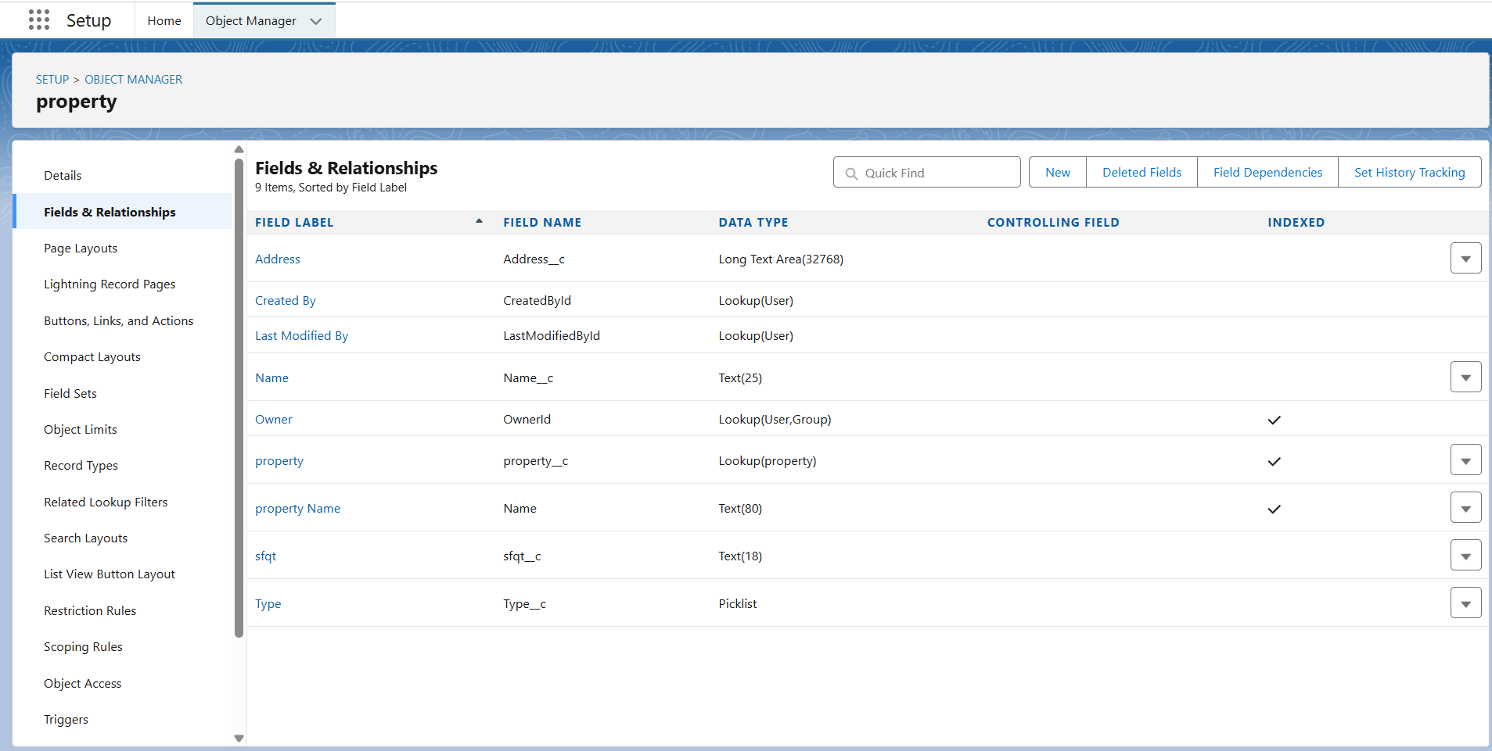

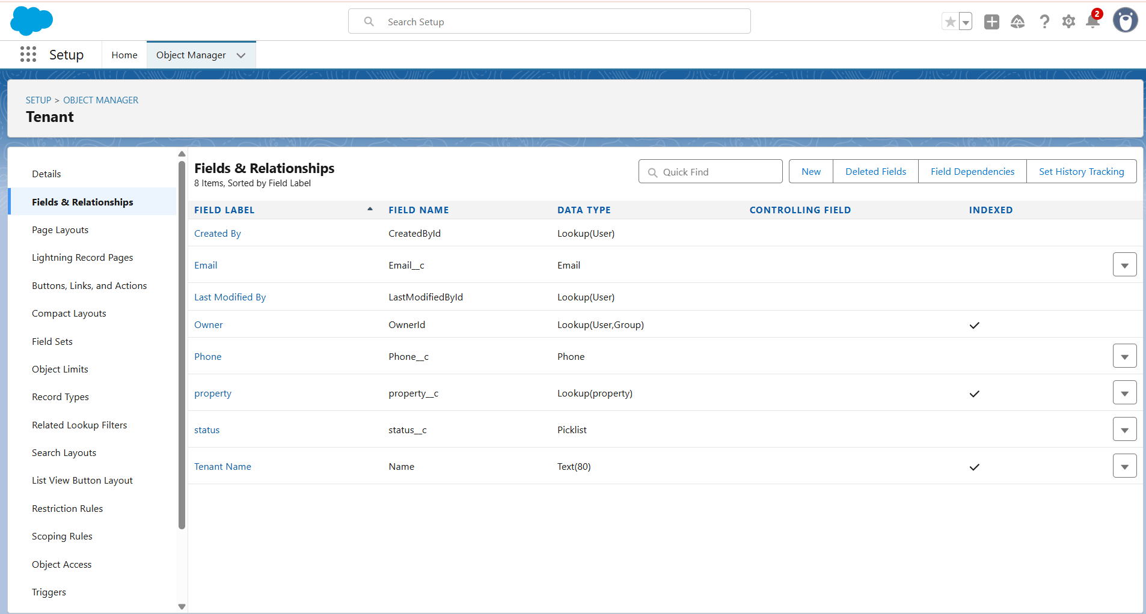

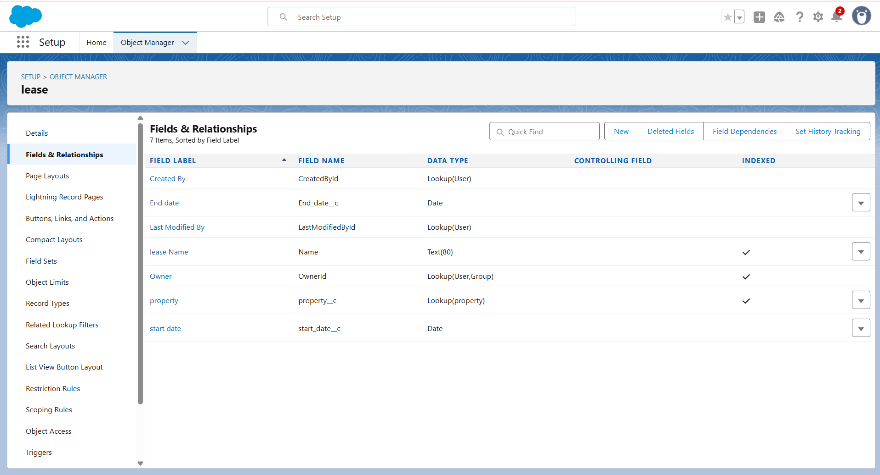

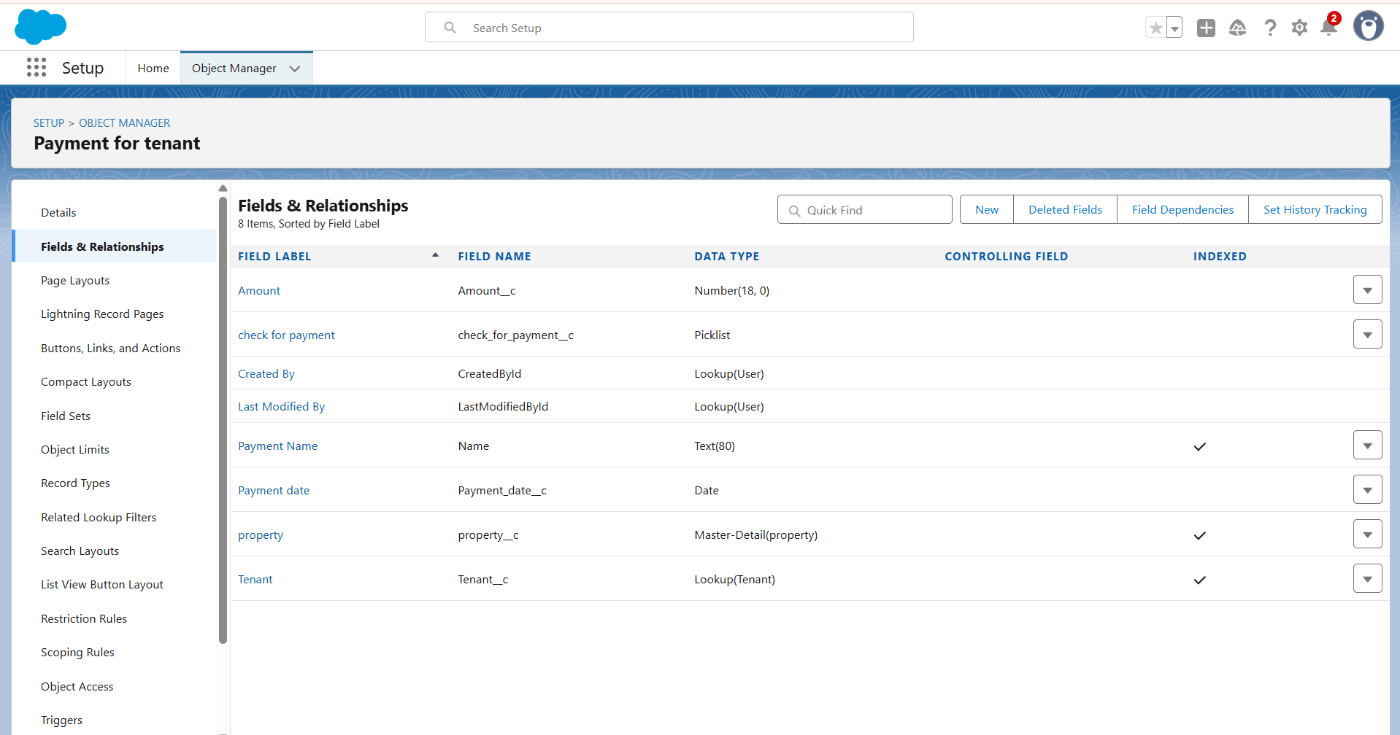

**THE LIGHTNING APP**

Developed Lightning App with relevant tabs

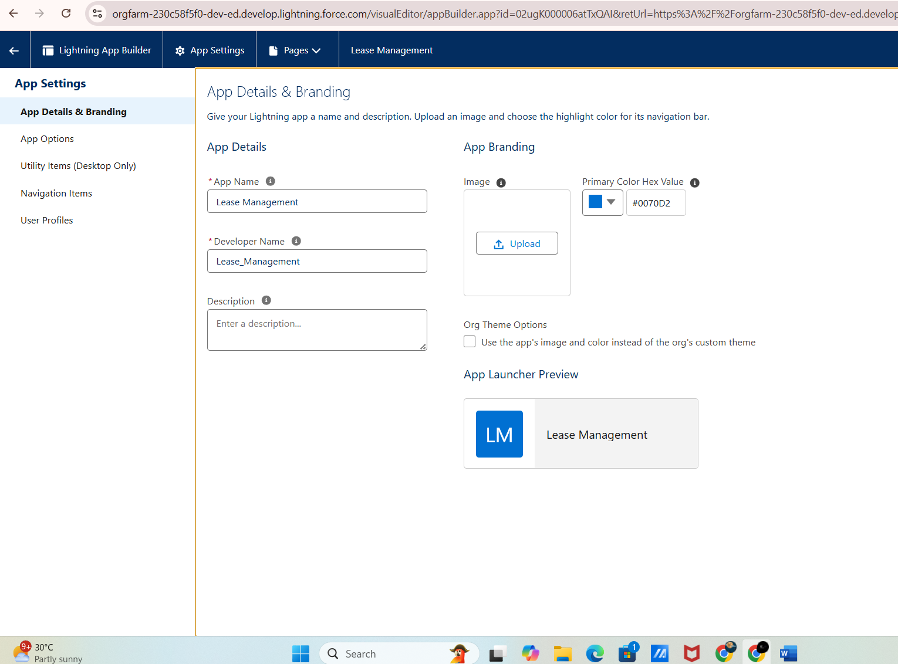

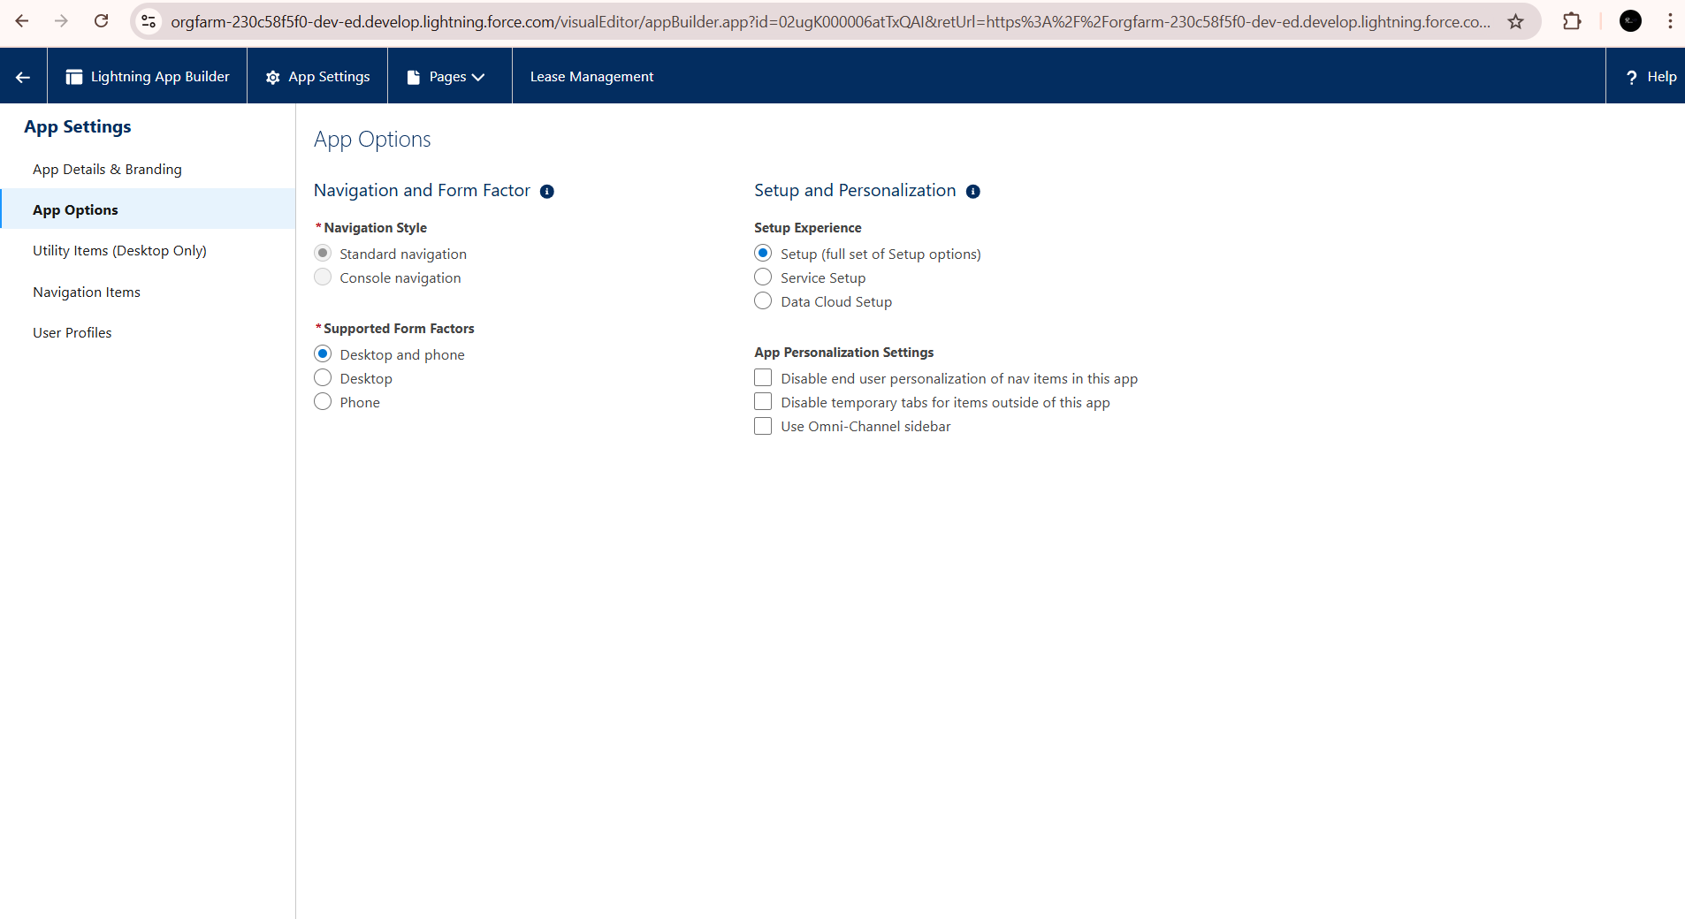

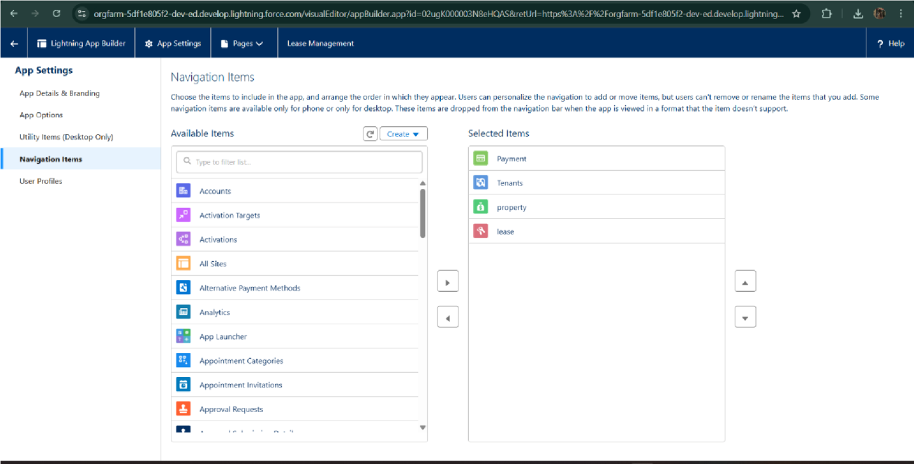

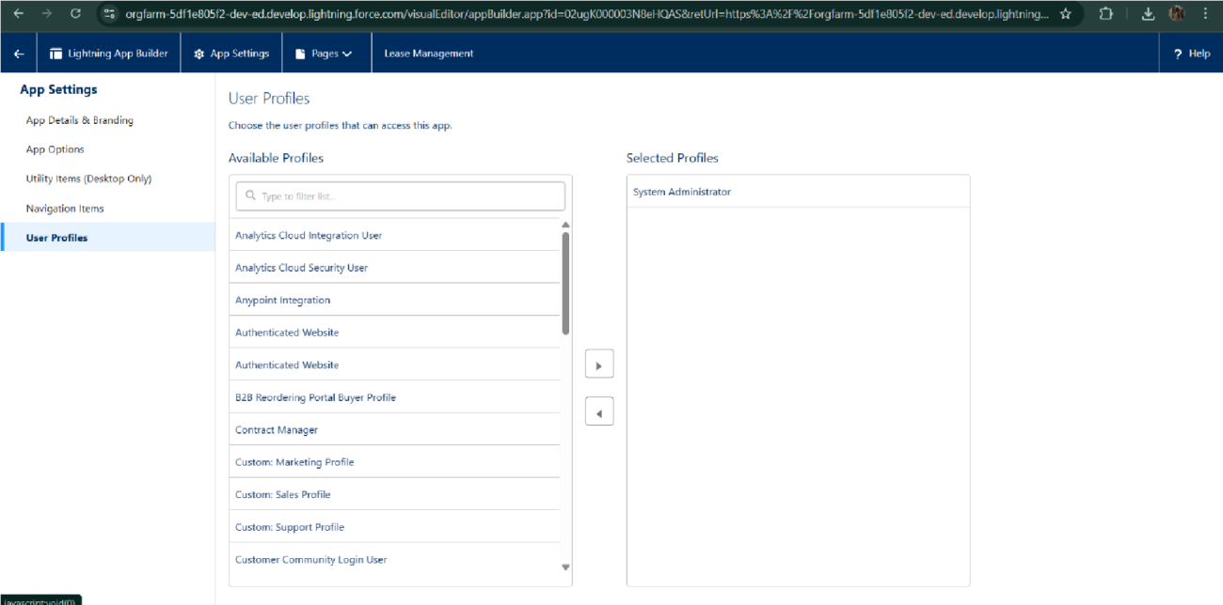

**VALIDATION RULE**

To create a validation rule to a Lease Object

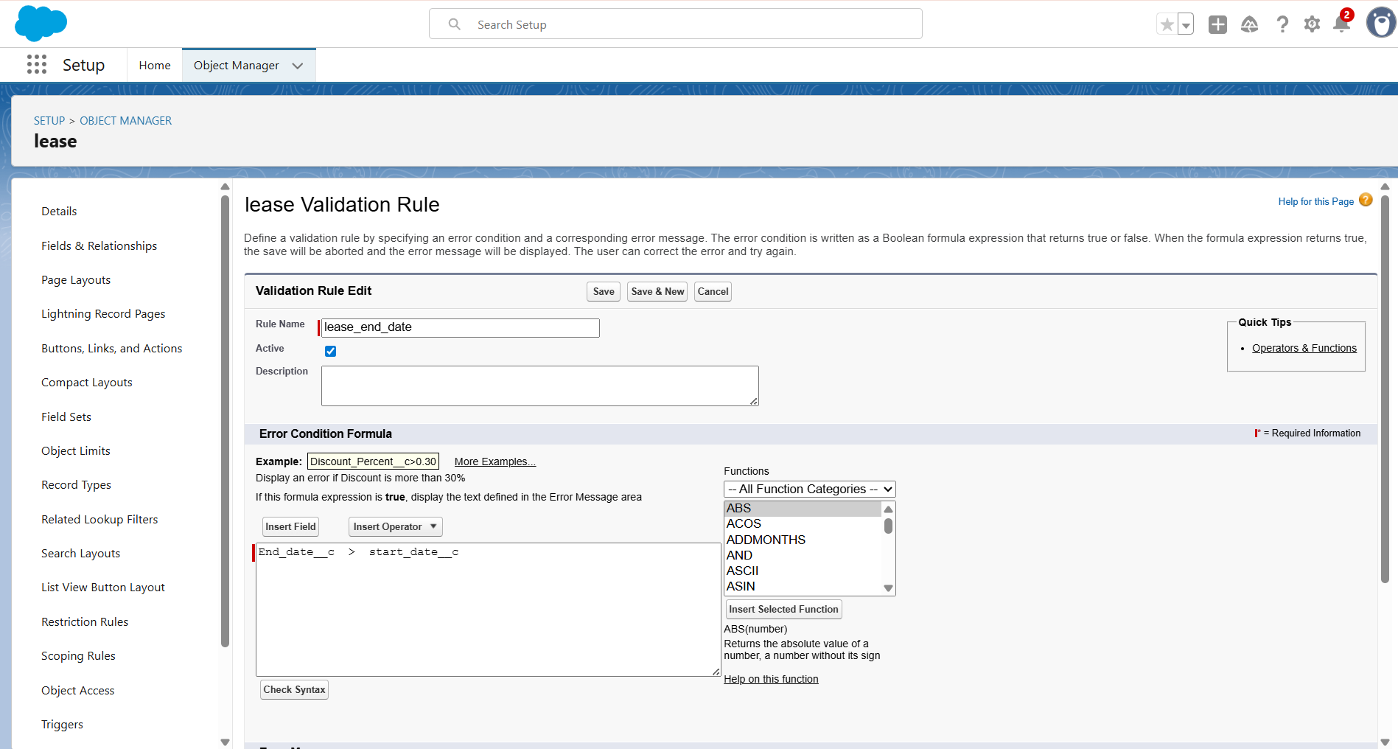

**FLOWS**

Implemented Flows for monthly rent and payment success

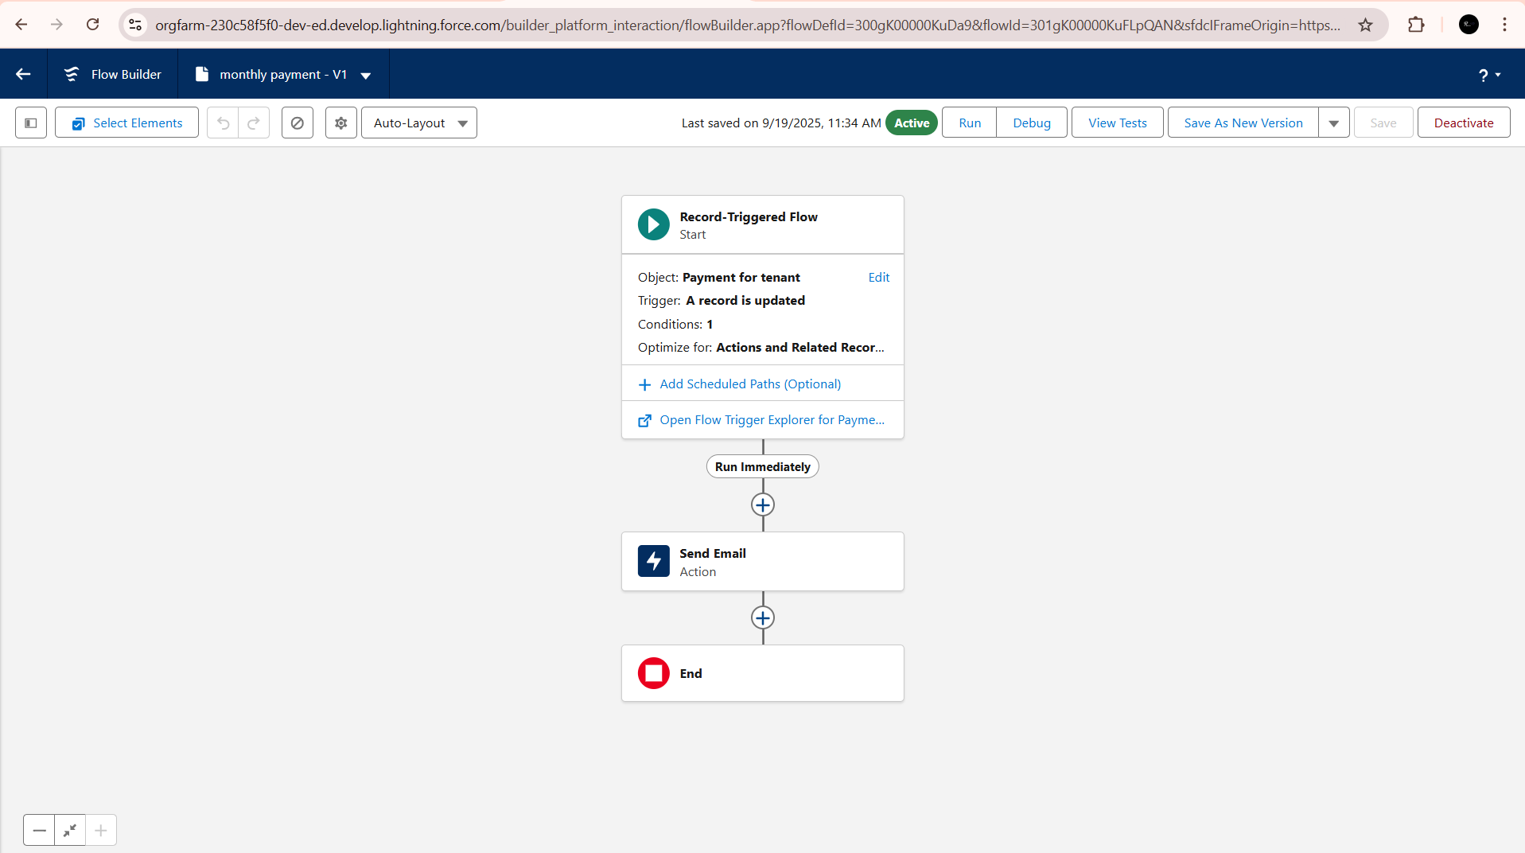

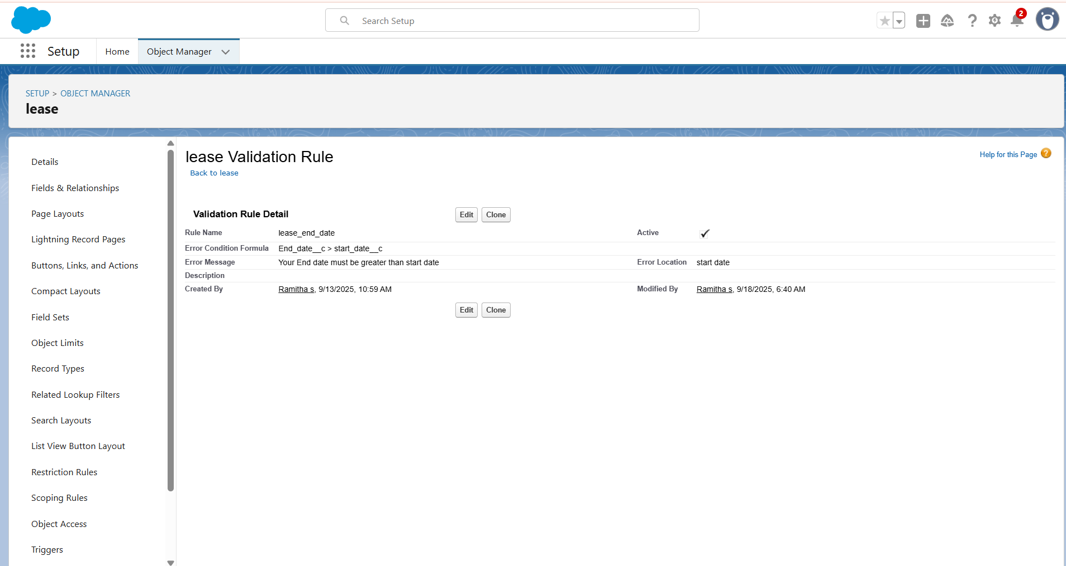

**EMAIL TEMPLATES**

Built and tested email templates for leave request, approval, rejection, payment, and reminders

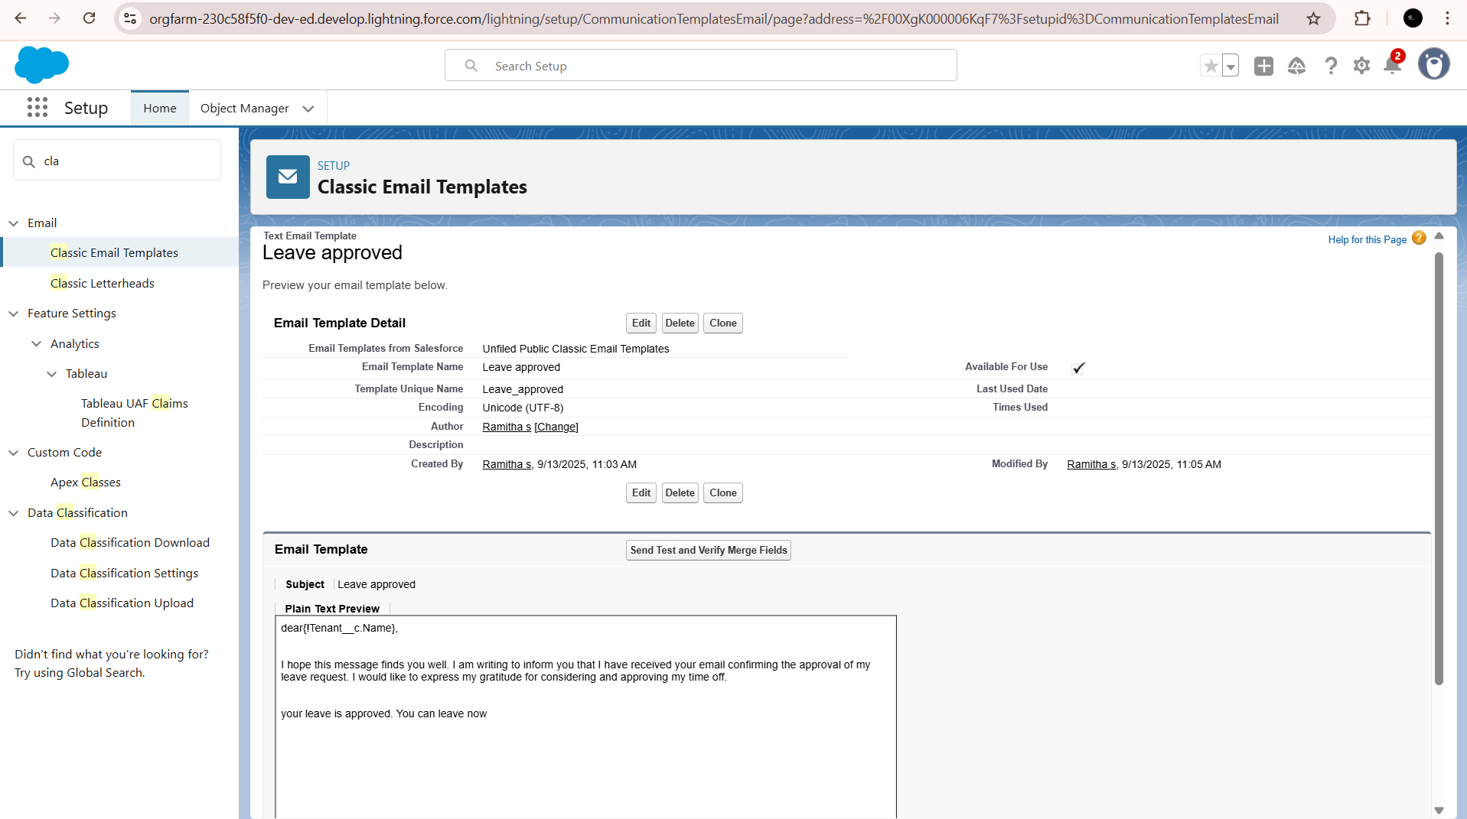



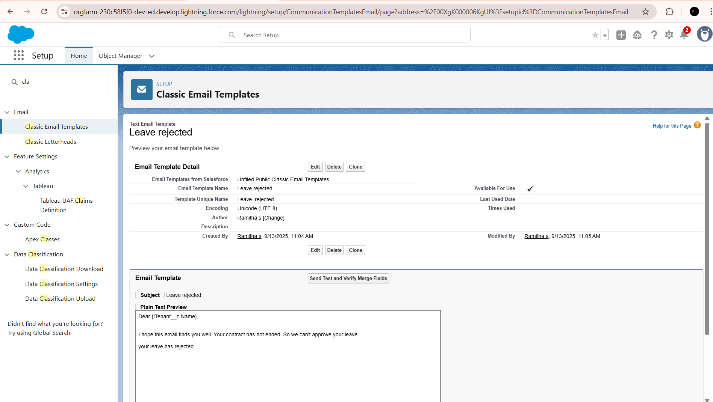

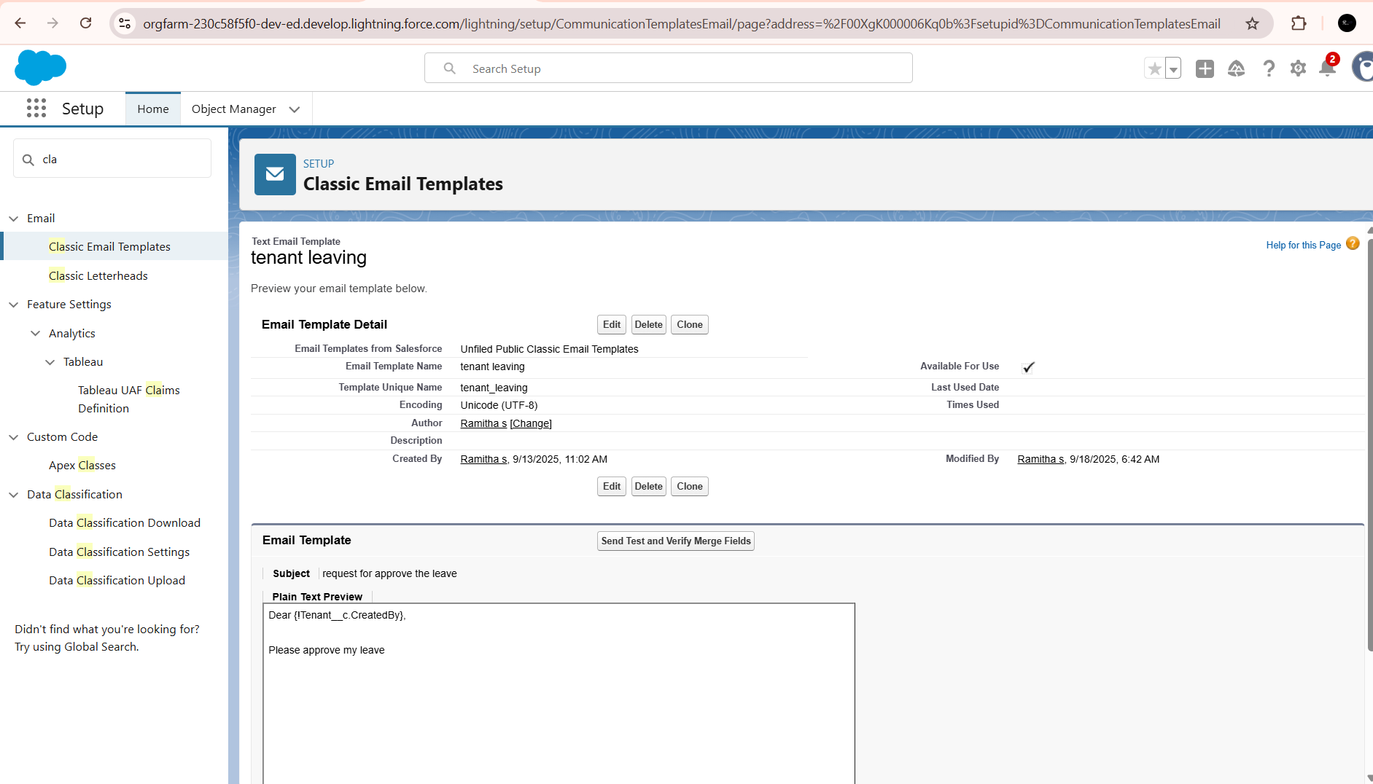

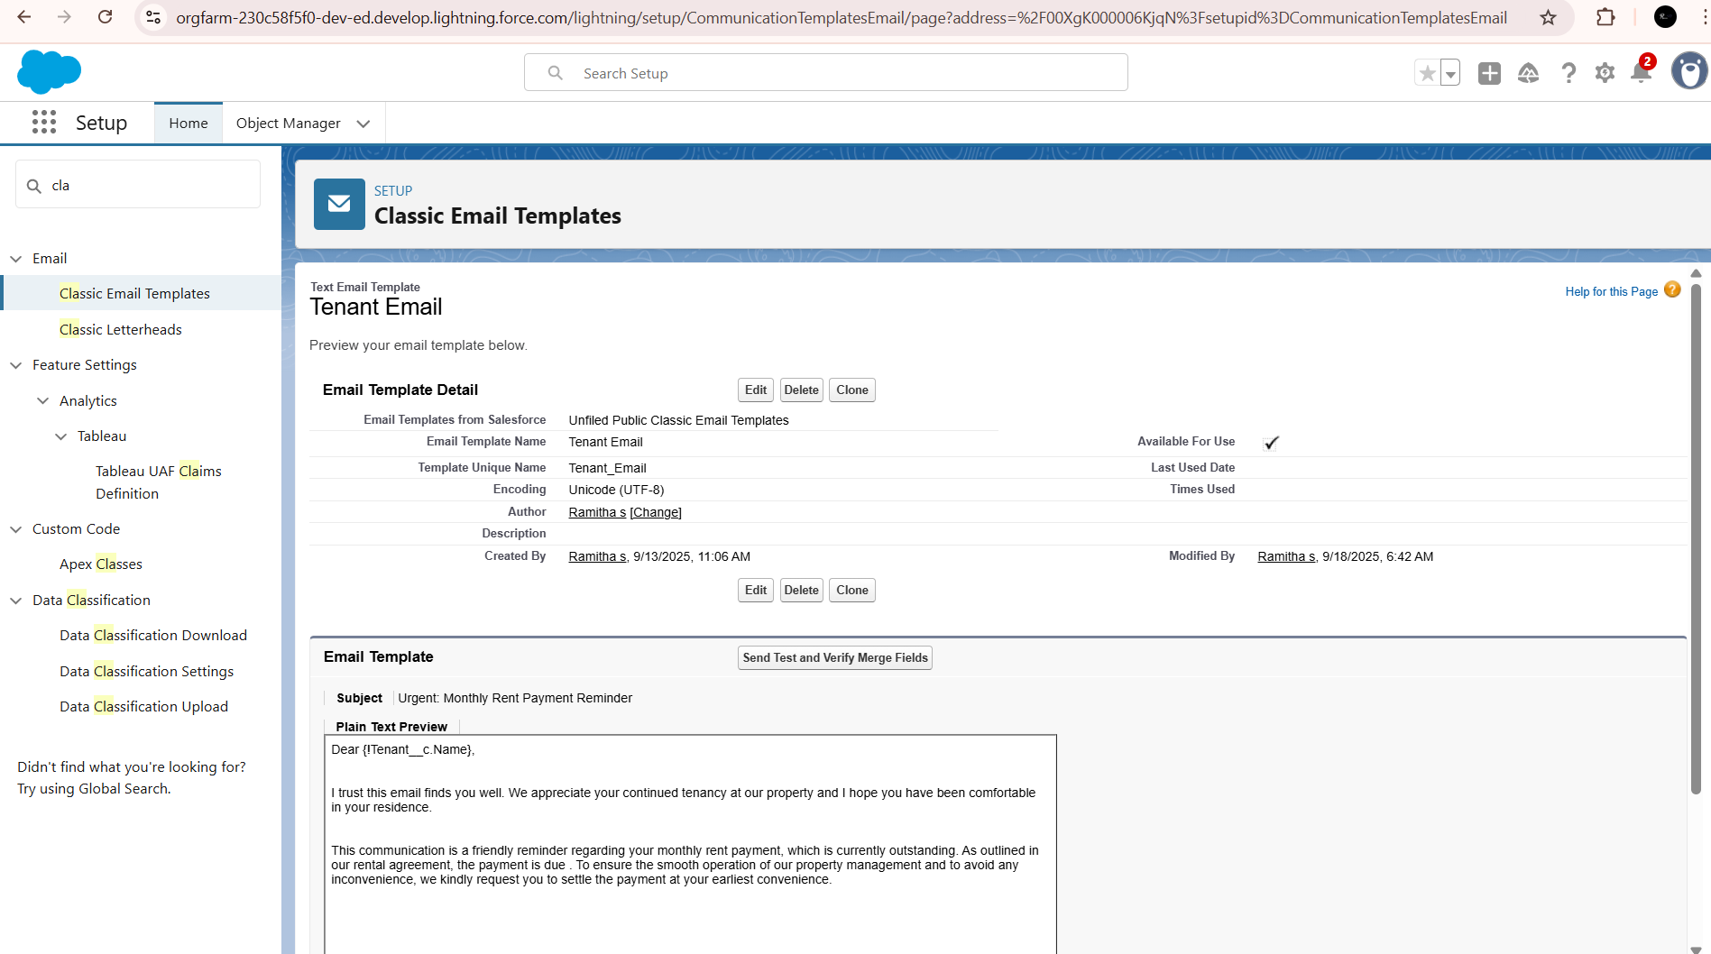

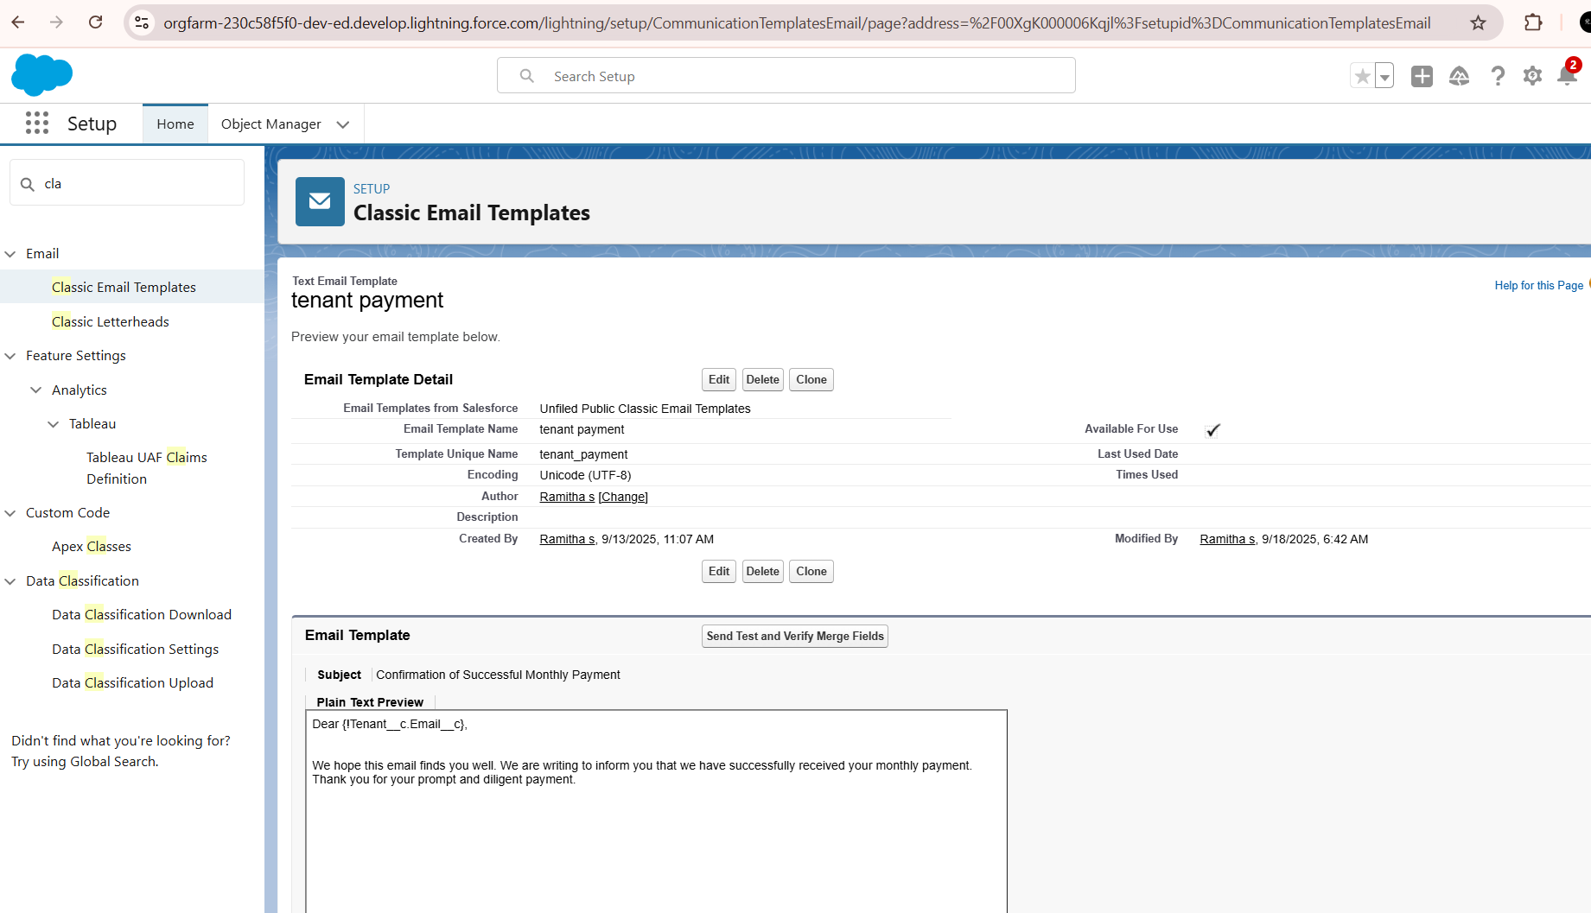

**APPROVAL PROCESSES**

Create Approval Process For check for vacant

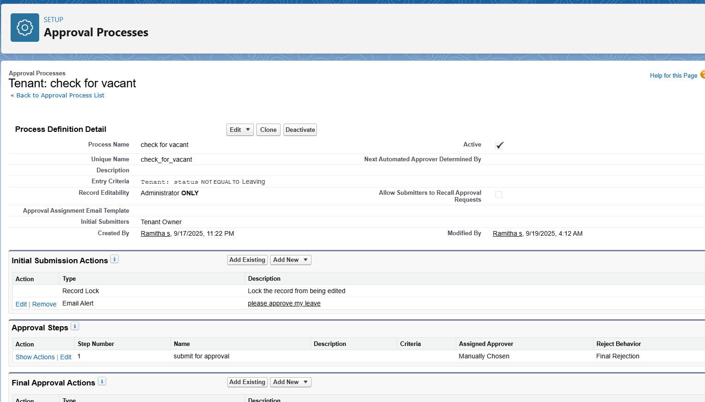

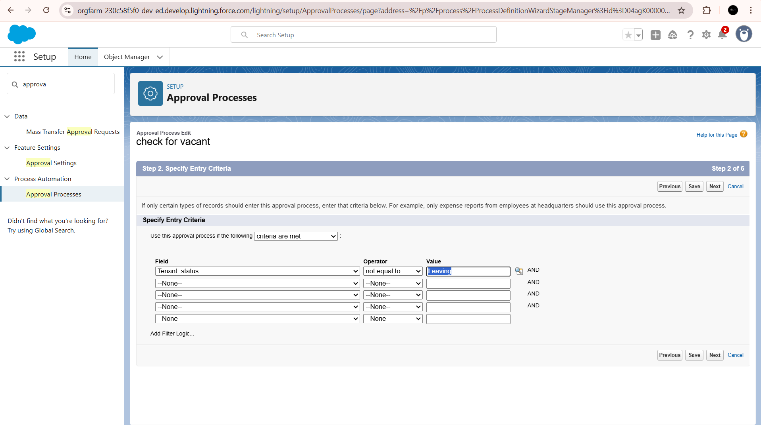

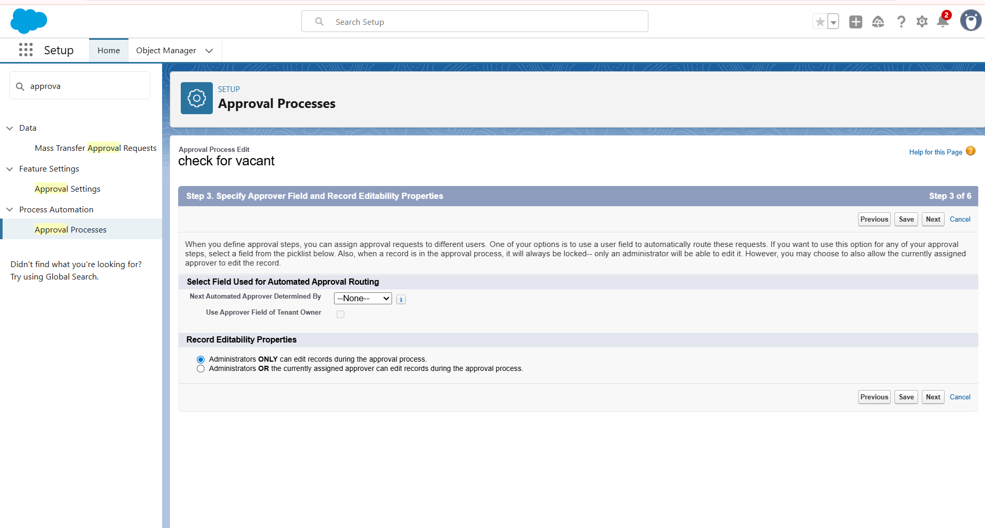

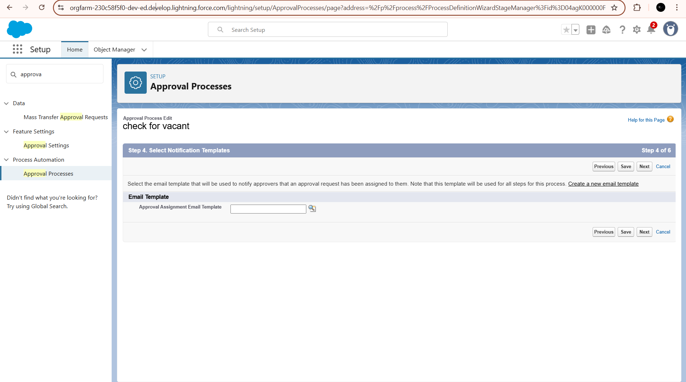

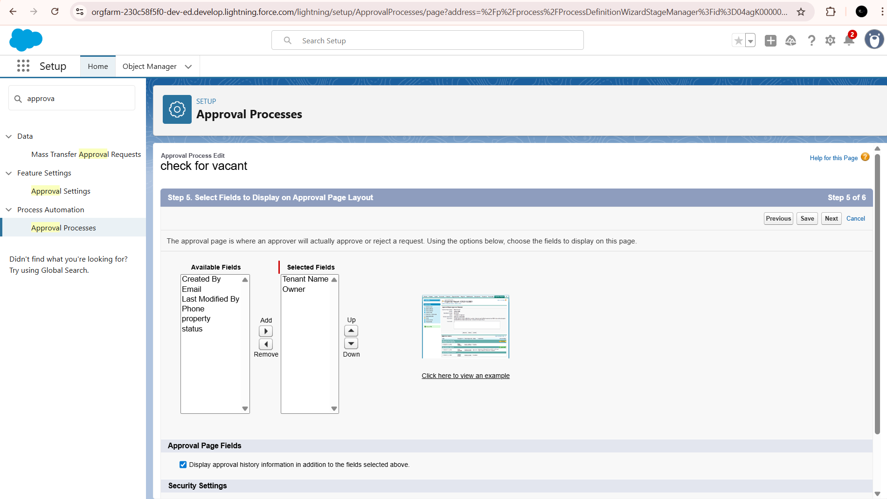

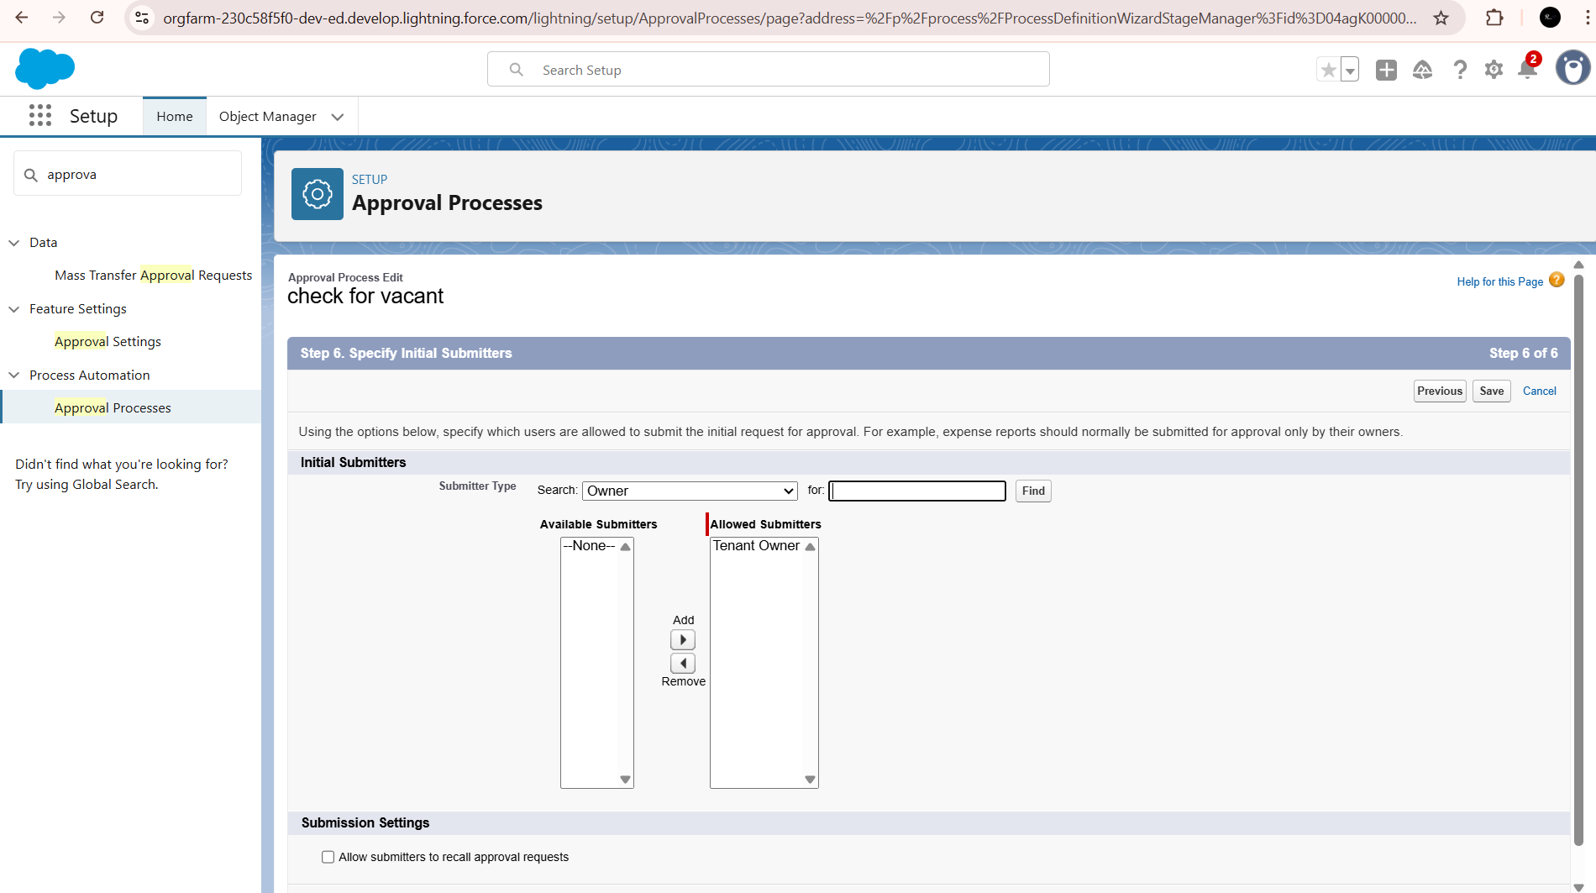

**APEX TRIGGER**

Create an Apex Trigger

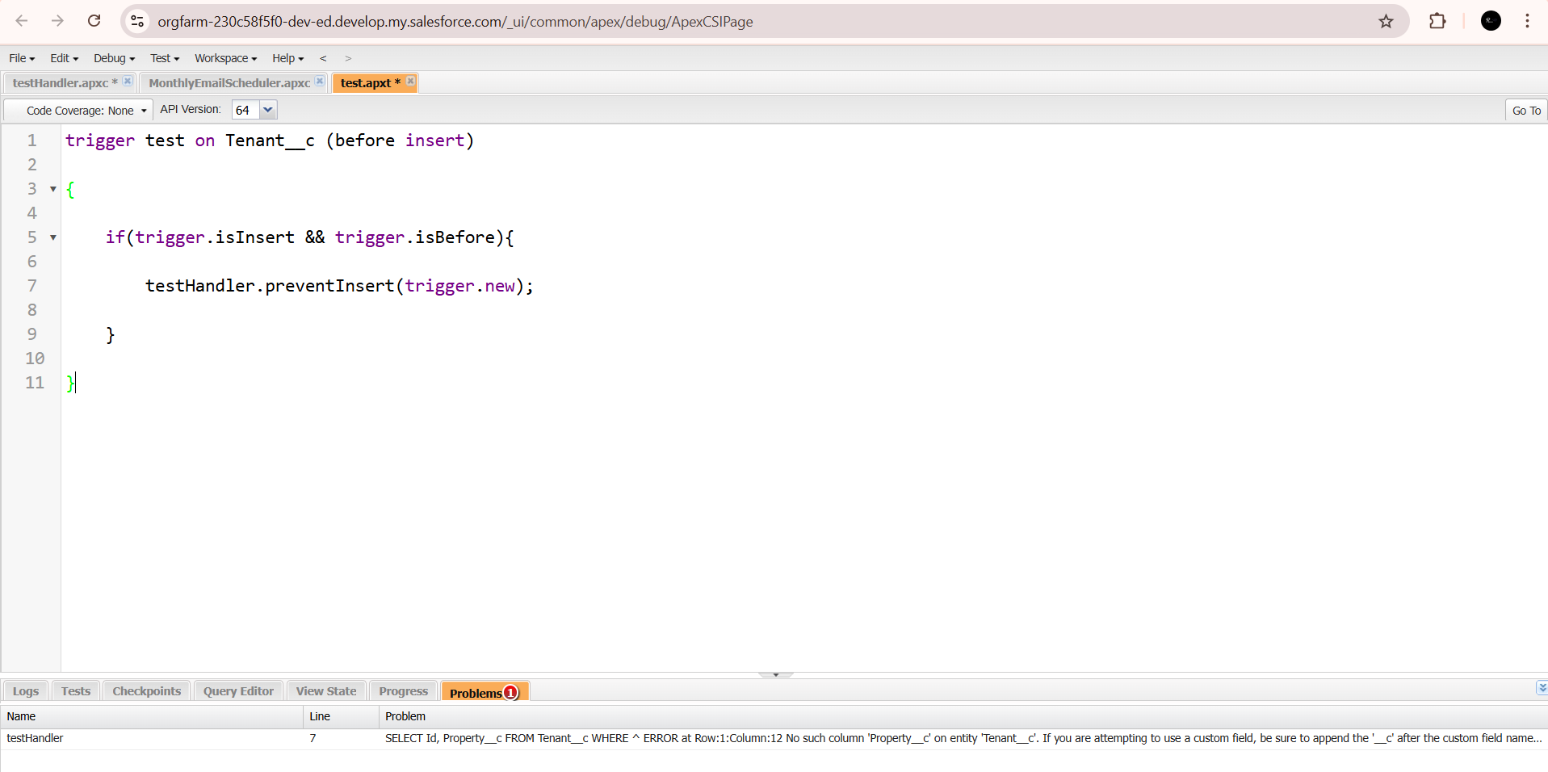

Create an Apex Handler class

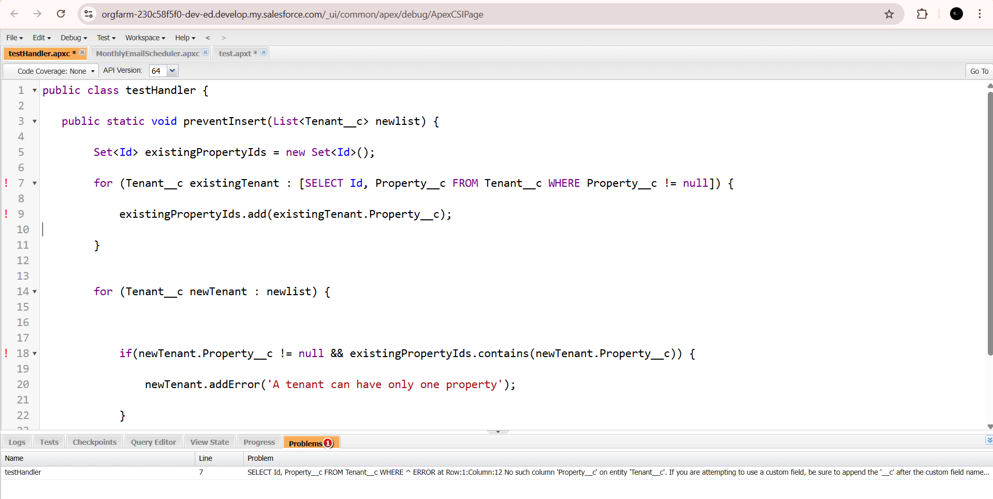

**SCHEDULE CLASS :**

Create an Apex Class

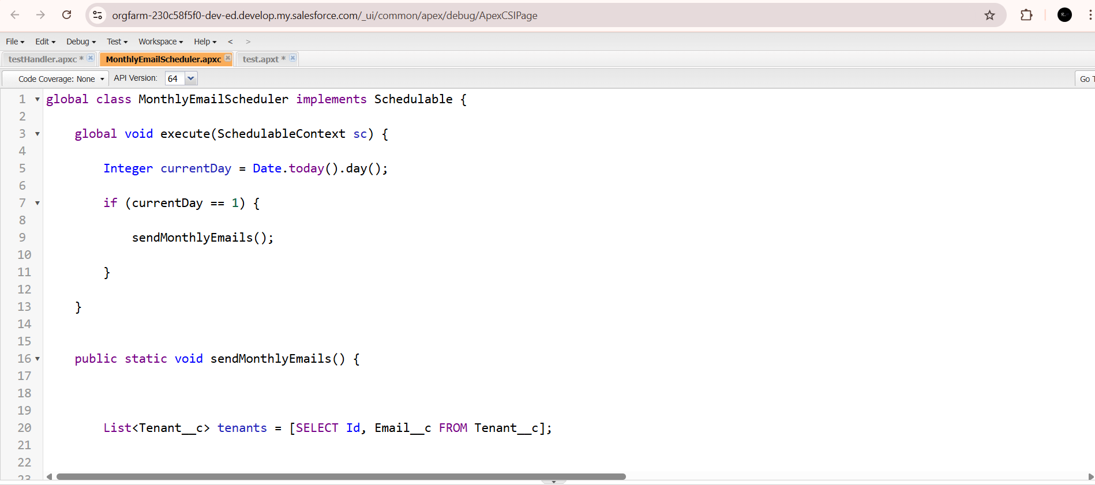

**SCHEDULE APEX CLASS**

Scheduled monthly reminder emails using Apex class

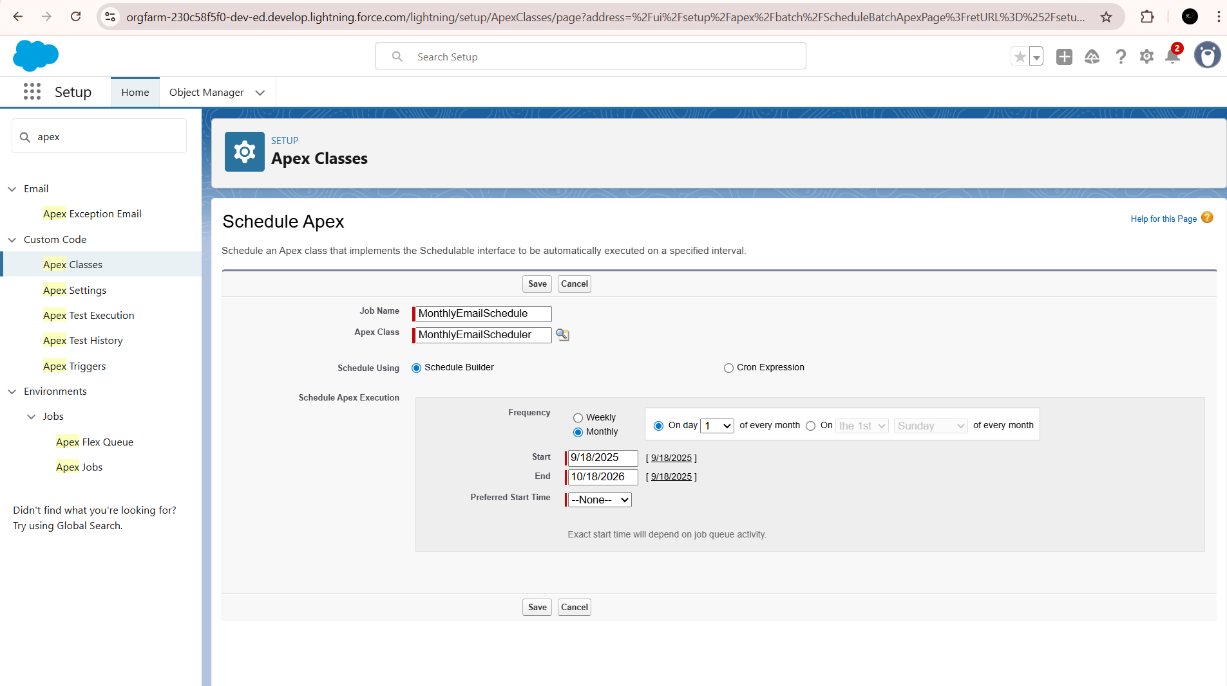

**FUNCTIONAL AND PERFORMANCE TESTING**

Performance Testing

Trigger validation by entering duplicate tenant-property records

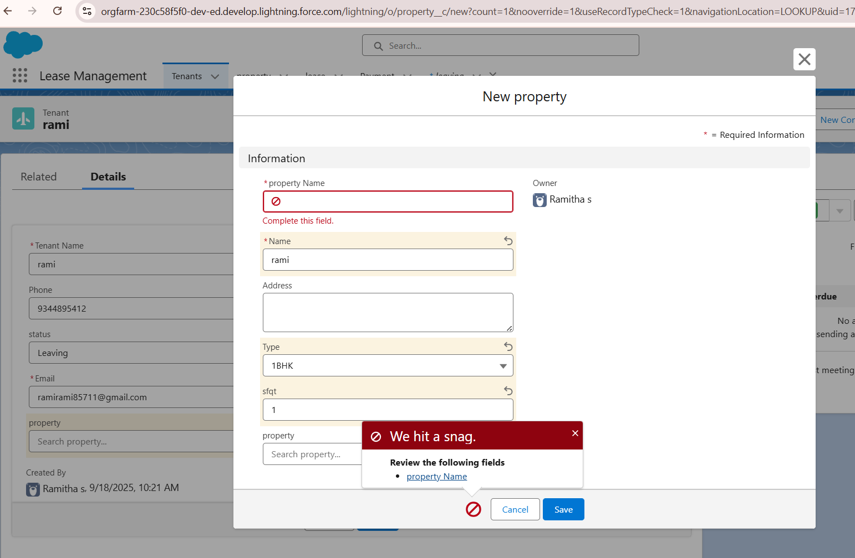

Approval process validated through email alerts and status updates

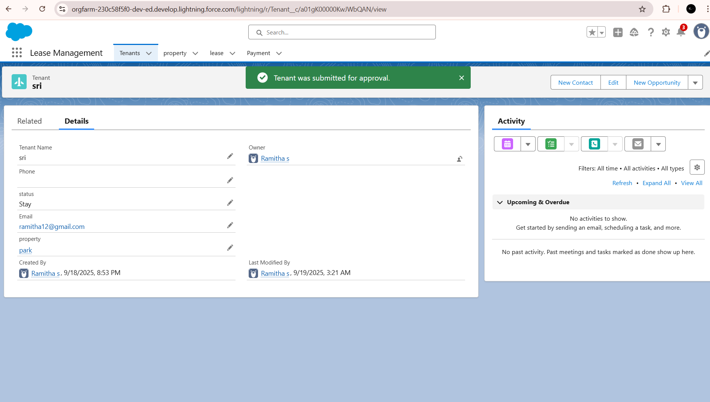

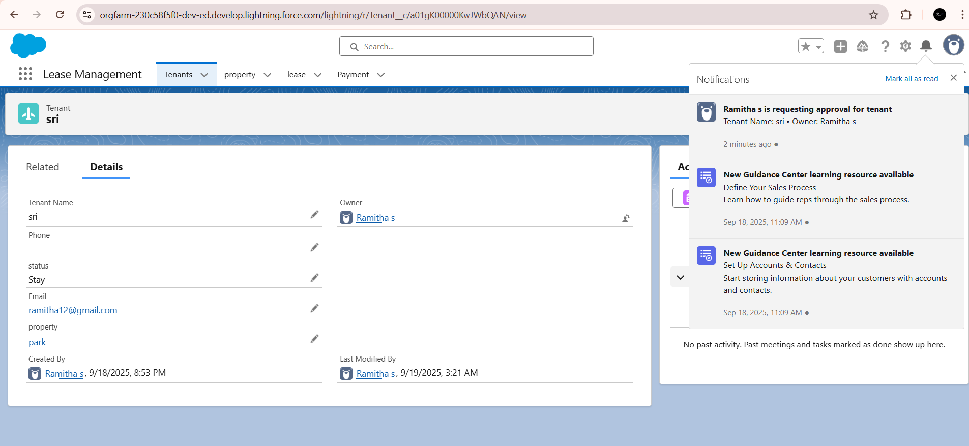

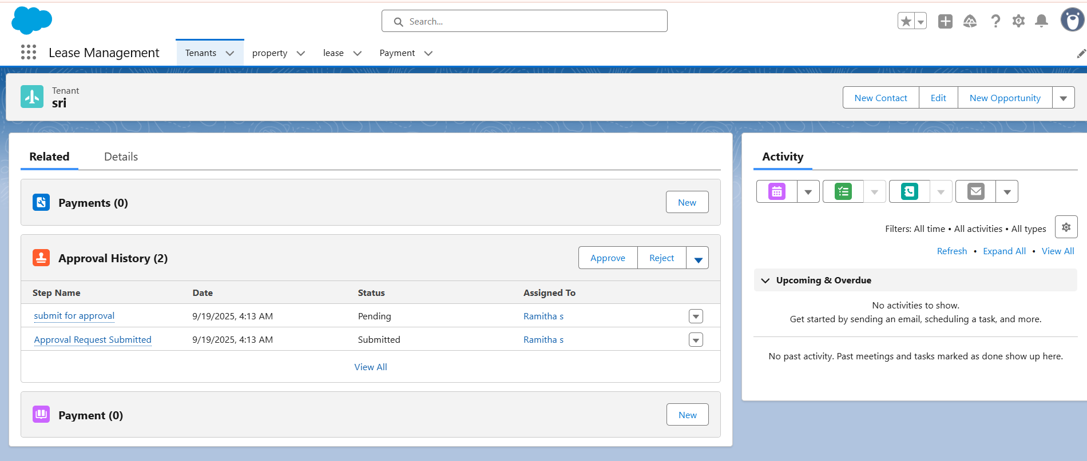

**VALIDATION RULE CHECKING:**

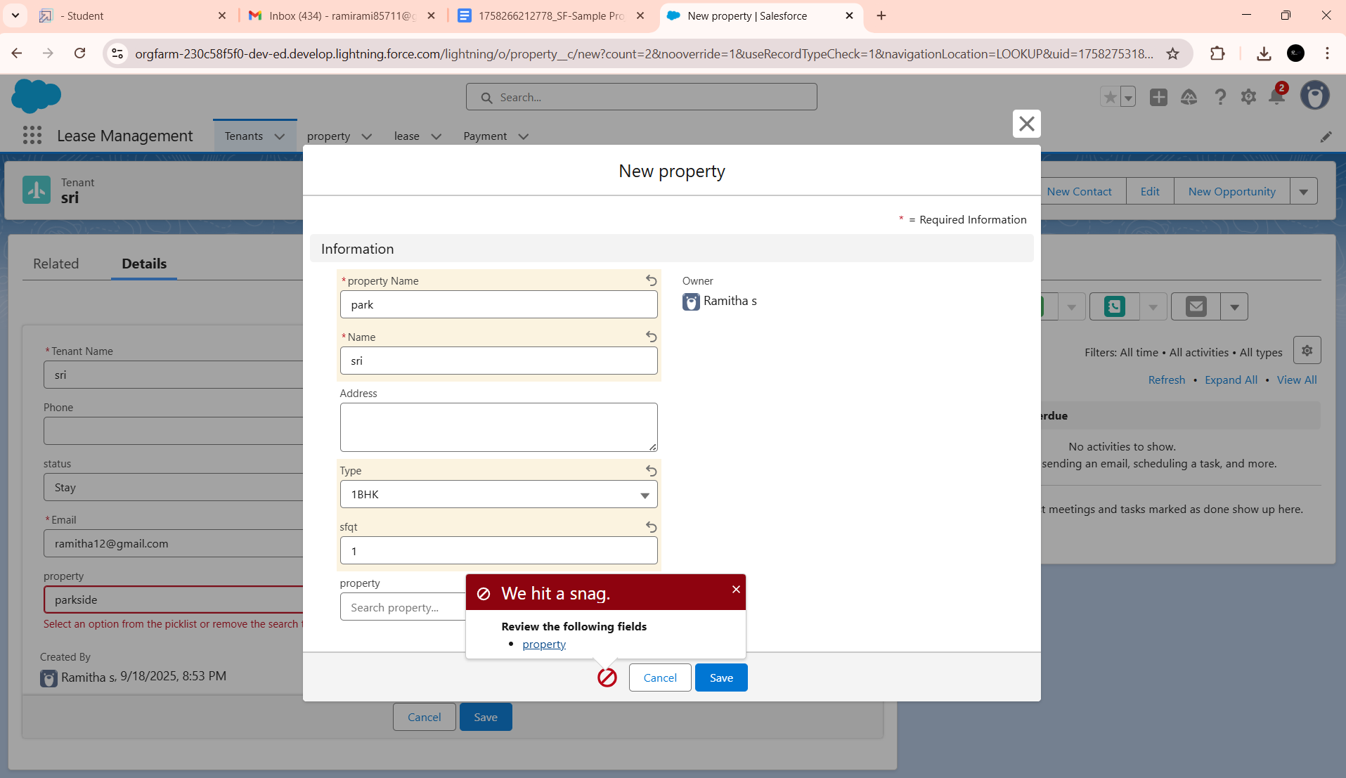

Added Apex trigger to restrict multiple tenants per property

**Test flows on payment update**

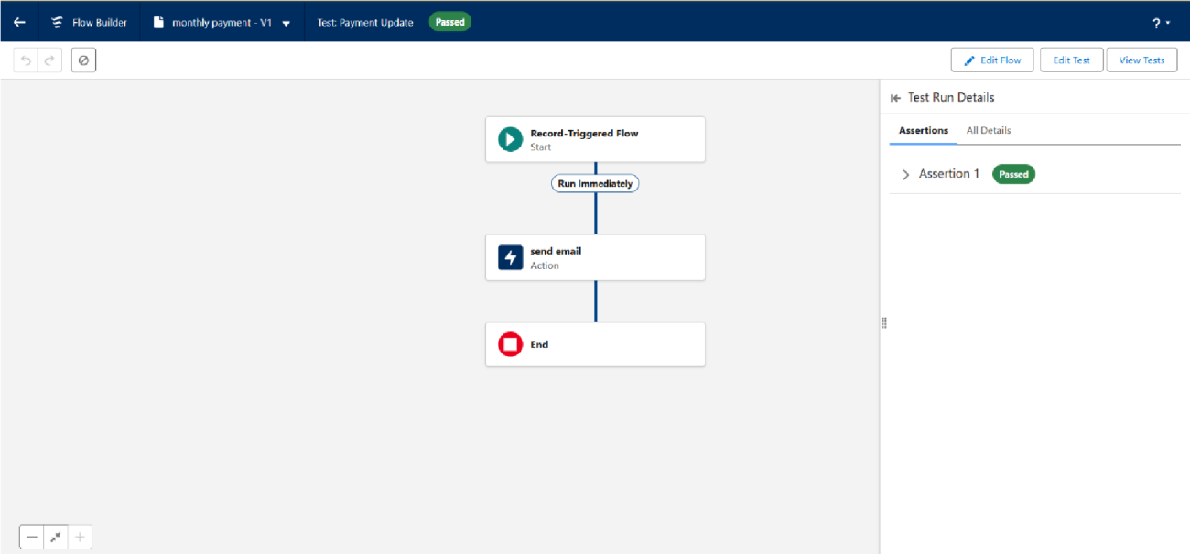

**RESULTS**

Output Screenshots

Tabs for Property, Tenant, Lease, Payment

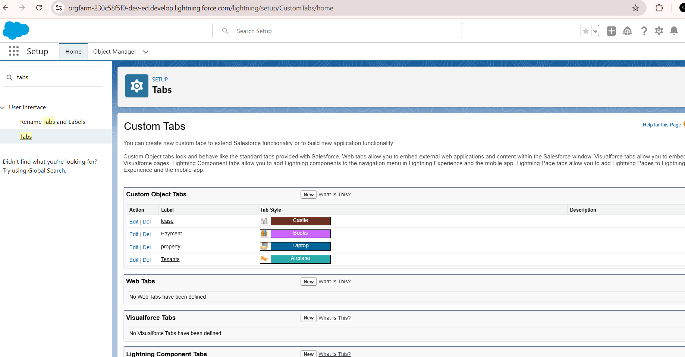

**EMAIL ALERTS**

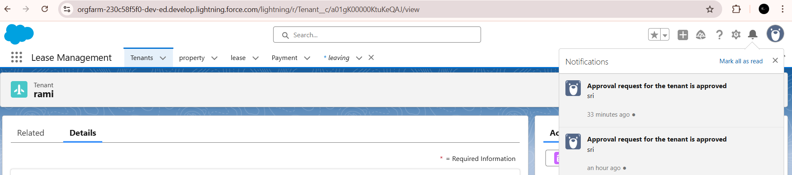

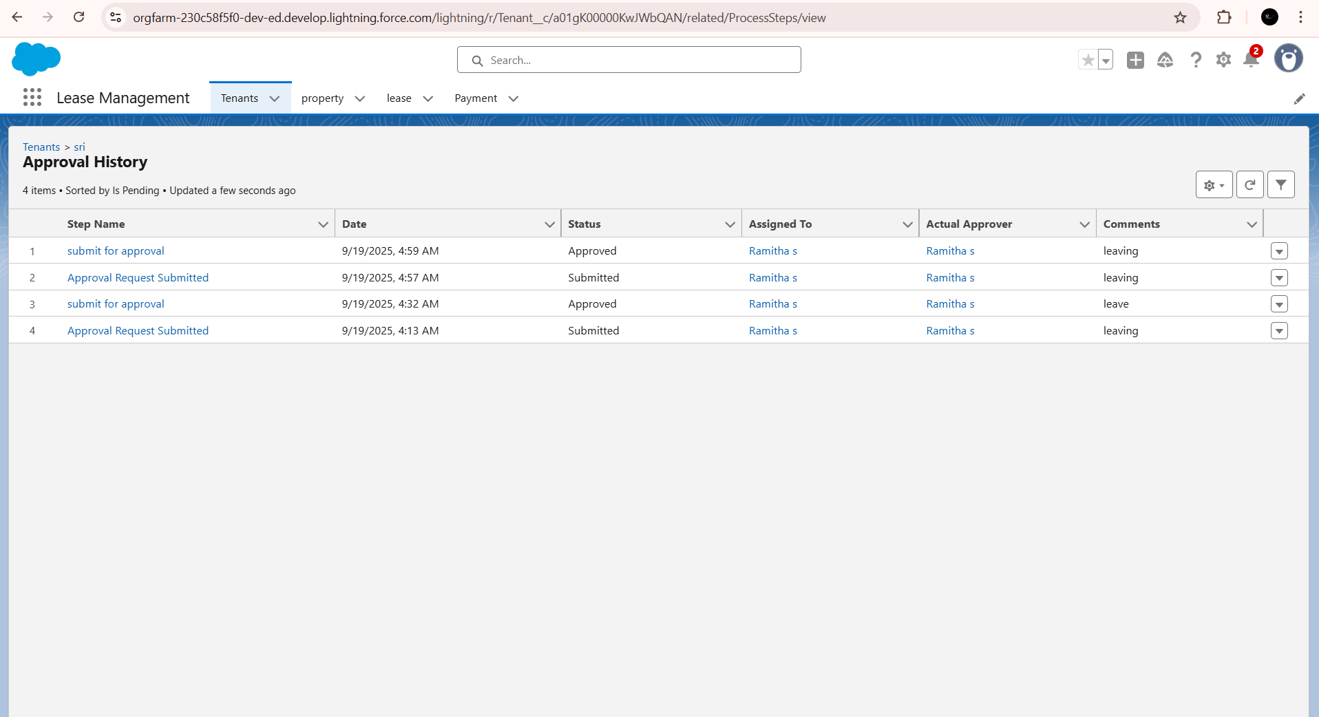

**EMAIL APPROVAL**

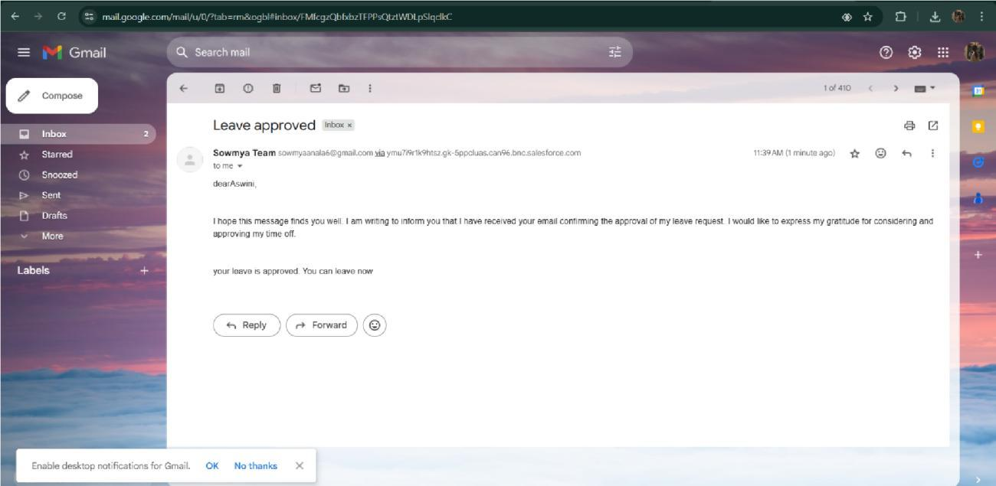

**FLOW RUNS**

